1. Please Install git & next Tortoise Git 2.5 has to be installed for GIT Windows.

2. Please use the clone to clone the repository

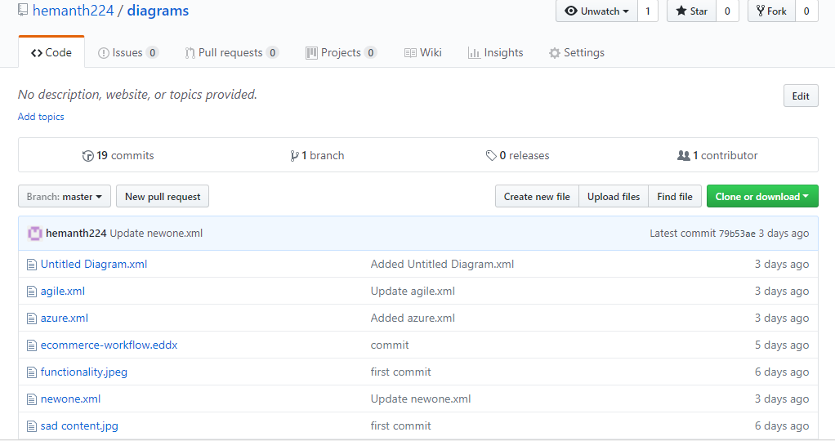

3. After cloning & Installing Tortoise git, use git clone to clone the repository

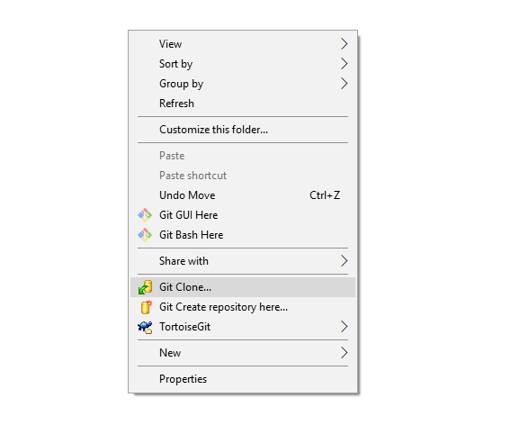

4. After cloning, You can perform the version changes as required.

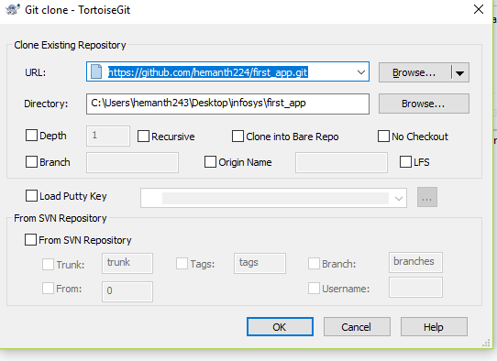

5. After cloning you can check the latest repository has been cloned with green symbol.

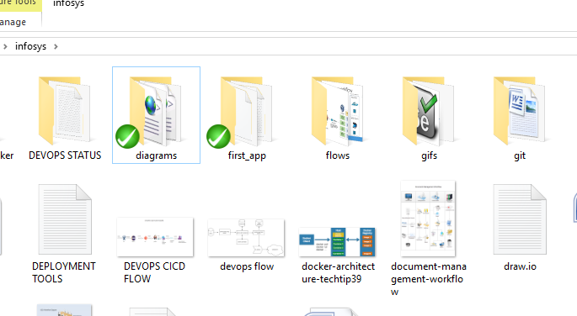

6. When trying to commit or push the new changes

a. Try to pull the repository so we can get latest repository

b. Next add the new changes to repository

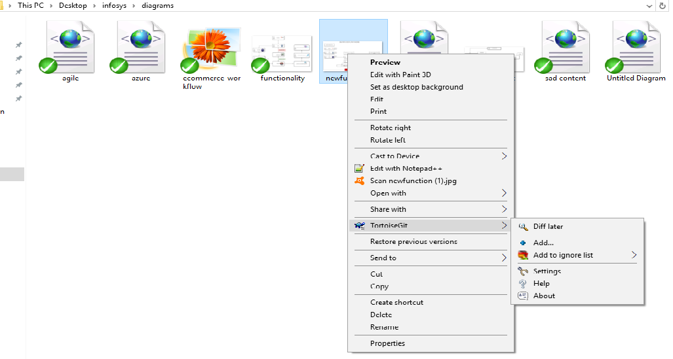

c. After adding commit the new changes

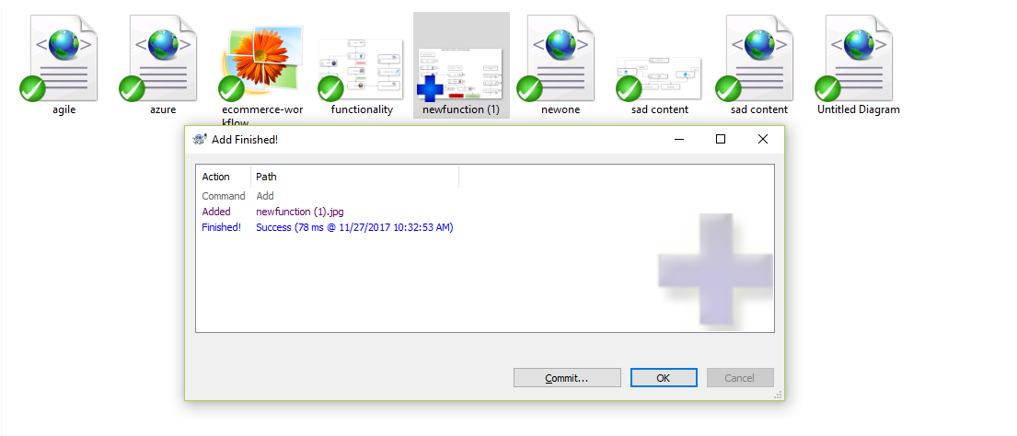

d. Commit with a message to get committed.

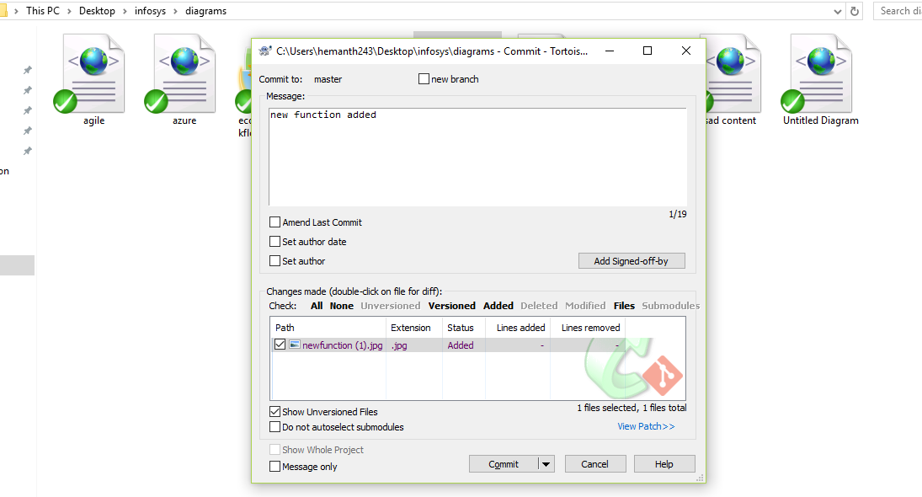

7. After success, Push the latest code to repository

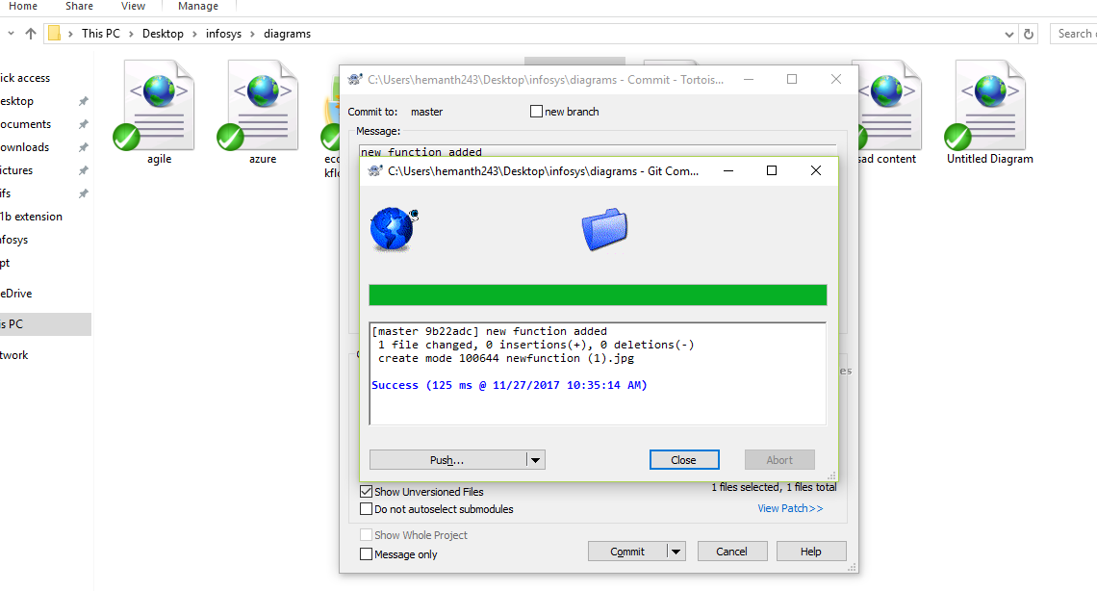

8. We can push to either one of the branches, Master or any other branch

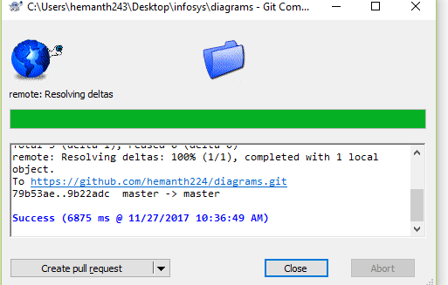

9. Check the repository whether latest branch has been committed and pushed.

